Module 7) JQuery Basic, Effects & Advanced
1. What is JQuery?
Ans. jQuery is a fast, small, and feature-rich JavaScript library. It makes things like HTML document traversal and manipulation, event handling, animation, and Ajax much simpler with an easy-to-use API that works across a multitude of browsers. With a combination of versatility and extensibility, jQuery has changed the way that millions of people write JavaScript.

2. How to Apply CSS Using JQuery, How to Add Class and Remove Class in JQuery, JQuery Animation?
Ans.
css using Jquery
input:
<!DOCTYPE html>
<html lang="en">
<head>
<meta charset="UTF-8">
<meta http-equiv="X-UA-Compatible" content="IE=edge">
<meta name="viewport" content="width=device-width, initial-scale=1.0">
<title>Document</title>
<script src="https://ajax.googleapis.com/ajax/libs/jquery/3.6.0/jquery.min.js"></script>
<!-- css function start -->
<script>

$(document).ready(function()
{
$(".b1").click(function()
{
$("p").css("background-color","red")
$("p").css("color","yellow")
})
$("div").click(function()
{

})
})
</script>
<!-- css function end -->
</head>
<body>
<p>Please Change My color</p>
<button class="b1">css</button>
<button class="b2">Animation</button>
<div></div>
</body>
</html>

Output:
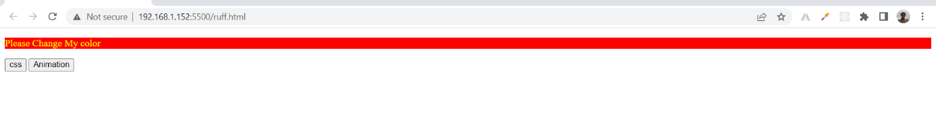

Add Class Remove Class
input:

<!DOCTYPE html>
<html lang="en">
<head>
<meta charset="UTF-8">
<meta http-equiv="X-UA-Compatible" content="IE=edge">
<meta name="viewport" content="width=device-width, initial-scale=1.0">
<title>Document</title>
<script src="https://ajax.googleapis.com/ajax/libs/jquery/3.5.1/jquery.min.js"></script>
<script>
// add function
$(document).ready(function()
{
$(".b1").click(function()
{
$("h1").addClass("class")
})
// remove function
$(".b2").click(function()
{
$("h1").removeClass("class")
})
})
</script>
<style>

.class
{
color: blue;
}

</style>
</head>
<body>
<h1>
Comapny Name
</h1>
<p>
Lorem ipsum dolor, sit amet consectetur adipisicing elit. Quidem suscipit eius illum, impedit a culpa delectus ipsum eligendi adipisci, id harum quam, possimus ut eum consequuntur totam ab. Quibusdam, reiciendis?
</p>
<!-- button start -->
<button class="b1">Add CSS</button>
<button class="b2">Remove CSS</button>
<!-- button end -->
</body>
</html>
Output:
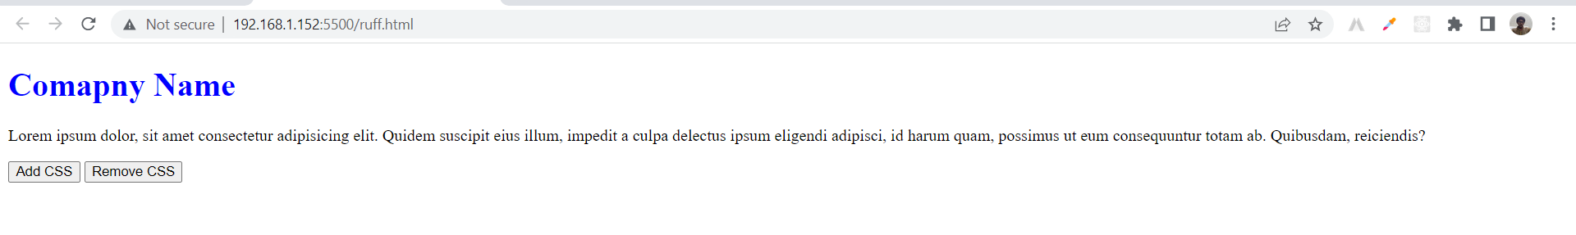

Jquery Animation
input:

<!DOCTYPE html>
<html lang="en">
<head>
<meta charset="UTF-8">
<meta http-equiv="X-UA-Compatible" content="IE=edge">
<meta name="viewport" content="width=device-width, initial-scale=1.0">
<title>Document</title>
<script src="https://ajax.googleapis.com/ajax/libs/jquery/3.6.1/jquery.min.js"></script>
<style>
/* css start */
div
{
height: 150px;
width: 150px;
background-color: blue;
left: 50%;
position: relative;
}
/* css end */
</style>
</head>
<body>
<button>Left</button>
<div>

</div>
<script>
// left function start
$(document).ready(function()
{
$("button").click(function()
{
$("div").animate({left:'50'});
})
})
// left function end
</script>
</body>
</html>
Output:
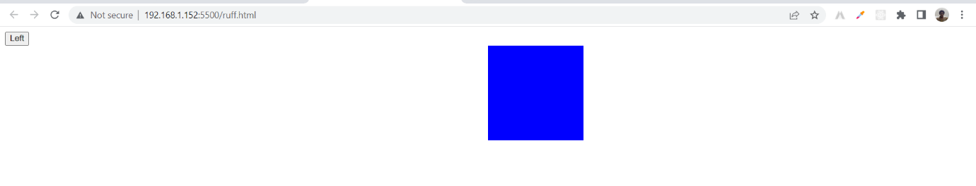

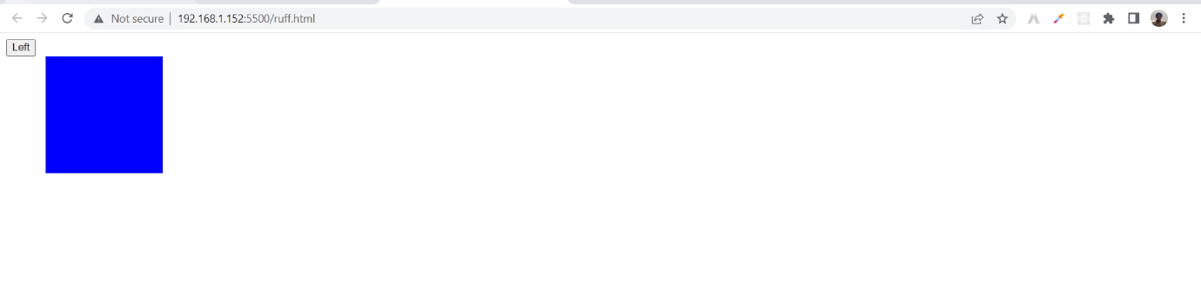

3. How to create slider with animation?
Ans.
input:

<!DOCTYPE html>
<html lang="en">
<head>
<meta charset="UTF-8">
<meta http-equiv="X-UA-Compatible" content="IE=edge">
<meta name="viewport" content="width=device-width, initial-scale=1.0">
<title>Document</title>
<script src='https://code.jquery.com/jquery-3.6.0.min.js'></script>
<!-- cycle.min.js -->
<script src="https://malsup.github.io/jquery.cycle.all.js"></script>
</head>
<body>
<div id="slide">
<!-- first img link -->
<img src="https://www.freecodecamp.org/news/content/images/2022/04/derick-mckinney-oARTWhz1ACc-unsplash.jpg" height="312px" width="450px" class="slider">
<!-- second img link -->
<img src="https://imagekit.io/blog/content/images/2019/12/image-optimization.jpg" height="312px" width="450px" class="slider">
<!-- third img link -->
<img src="https://st2.depositphotos.com/1670531/7635/i/600/depositphotos_76357499-stock-photo-top-view-office-desk-mockup.jpg" height="312px" width="450px" class="slider">
</div>

<!-- slider apply here -->
<script type="text/javascript">
$(document).ready(function()
{
$("#slide").cycle("fade");
$("#slide img").css("overflow-y","hidden");
});
</script>
</body>
</html>
Output:
